#### Year 10 Commerce

#### Assessment Task DUE WEEK 6 AUTUMN TERM 2017

**INVESTIGATION –**

**INVESTING IN THE 21st CENTURY (2017)**

**Name: Jamie Coulson**  **Teacher: Mr. Kandiah**

**Statement of Inquiry:**

*The Australian and international financial system impacts on you so we need to understand how to participate in the system.*

**Key Concept:** *Time, place and space, Change, Global Interactions*

**Related Concepts:** *Choice, Ethics, Governance, Government, Leadership, Patterns and trends*

**Global Context:** *Globalisation and sustainability*

**Assessed Criteria:**

**Criterion A – Knowing and Understanding**

* use a wide range of terminology in context
* demonstrate knowledge and understanding of subject-specific content and concepts through developed descriptions, explanations and examples.

**Criterion B – Investigating**

* formulate a clear and focused research question and justify its relevance
* formulate and follow an action plan to investigate a research question
* use research methods to collect and record appropriate, varied and relevant information
* evaluate the process and results of the investigation.

**Criterion C – Communicating**

* communicate information and ideas effectively using an appropriate style for the audience and purpose
* structure information and ideas in a way that is appropriate to the specified format
* document sources of information using a recognised convention.

**Criterion D – Thinking Critically**

* discuss concepts, issues, models, visual representation and theories
* synthesise information to make valid, well-supported arguments

**DUE DATE: WEEK 6 AUTUMN TERM 2017**

Students must complete Parts 1 and 2 with all written work in a report format complete with headings and sub headings.

As part of your research please utilise this website: <http://my.scotch.wa.edu.au/year10/commerce/investing>

**Part One: Investing**

You are a professional investor that has $1,000,000 that needs to invested for a high net-worth client of yours. Using your knowledge gained in class as well as additional research, formulate an investment strategy for your client to maximise their returns.

You are to invest, with the following parameters:

* No more than 20% is to be left in cash/government bonds.
* No more than 50% is to be invested overseas.
* You must invest in a minimum of four different investments, maximum of six.
* No investments in mining sector stocks or bonds in Australia.
* No investments that are unethical

**Wesfarmers Ltd (ASX:WES)**

Weighting: 25%

Cost of share: $42.62

Volume: 250,000 / 42.62 = 4,005 shares

Wesfarmers in an Australian Conglomerate which owns a variety of businesses in many different sectors. This gives the company great financial stability.

Wesfarmers recently acquired HOMEBASE in the UK and have used it as a framework to base their Bunnings UK expansion. The recent expansion of the Bunnings franchise has aided Wesfarmers financial growth and has also opened them to a completely new market. This will allow for even further expansion of Wesfarmers franchises into the UK if the Bunnings expansion into the UK is successful. If the expansion is successful a massive rush of profit and economic growth will go into Wesfarmers and if the expansion fail the many different other businesses that the company owns will be able to hold it on its feet and deliver a stable divided of $2 and is therefore low risk.

**Australian and New Zealand Banking Group (ASX:ANZ)**

Weighting: 25%

Cost of share: 28.22

Volume: 250,000 / 28.22 = 8,858 shares

Australian and New Zealand Banking Group is the fourth largest bank by market capitalisation in Australia.

ANZ is one of the big four banks in Australia which allows for the government to secure the deposits in the bank up to $250,000 which give the

**NVIDIA Corporation**

Weighting: 25%

NVIDIA Corporation is a Technology Design and Manufacturing company that mainly produces Graphics Processing Units (GPU) for the gaming and professional market. NVIDIA have a forecasted dividend of 0.50c for the next two year which represents a 22.78% increase of the dividend of the previous year.

The company recently released its new flagship GPU the GeForce GTX 1080 Ti which drastically increased the stock price of the company. With rumours of the company releasing a new high end GTX Titan (NVIDIA’s most high end GPU unit) later this year the company is sure to continue to grow. As companies become more and more reliant on software to preform everyday commands and tasks the need for more powerful computing systems will grow and increase the demand for more GPU’s leading to the companies demand to slowly increase which will lead to an increase in the stock price and dividend which is already increasing.

**Global Construction Services Limited**

Global Construction Services Limited (GCS) is a construction company based in Perth.

Brookfield recently acquired 15% of GCS and have funded them to acquire the majority of construction services on the east side of Australia to take advantage of the construction boom on the east side of Australia. This will give GCS monopoly over the construction industry on the east side of Australia during a massive boom in the demand for construction work on the east side of Australia. This should lead to a large increase in the stock price of GCS.

You will need to provide justification for each of your investments as well as a final summary paragraph on why the portfolio you have chosen is suited for your client.

**Part Two: ASX analysis**

You are to select **2 stocks listed on the ASX and complete the following analysis on both of the companies.**

**Complete each analysis on a separate piece of paper and write no more than one A4 sheet for each company.**

**1.** What does the company do?

**2.** When did the company first become a listed company?

**3.** Describe the general trend in the company’s share price over the last six months.

**4.** Describe the performance of this company’s share price compared to the All Ordinaries Index over the last six months.

**5.** What market sector does your company belong to? Look for the **Global Industry Classification Standard** (GICS) industry group.

**6.** Now that you know the sector your company belongs to, write a brief paragraph (100 words )about how this sector of the market has performed over the last 12 months. You will need to look at some charts to answer this question. How has this sector performed compared to the market as a whole? Can you think of any significant events that might have affected performance? For example, commodity prices, natural events affecting costs or demand, new technology breakthroughs.

**Investigation Organiser**Throughout your investigation, you will need to complete the attached investigation organiser to help you guide with your research in both Parts One and Two. This will determine your grade for Criterion B (Investigating).

NVIDIA Corporation ( NASDAQ:NVDA) Stock Analysis

NVIDIA corporation is a business that designs and manufactures graphics processing units (GPU) for gaming and professional uses. A GPU is a extension of a computer that provides the computer with more processing power. NVIDIA Corporation’s primary market sector is Technology Hardware, Storage and Peripheral. (45202030).

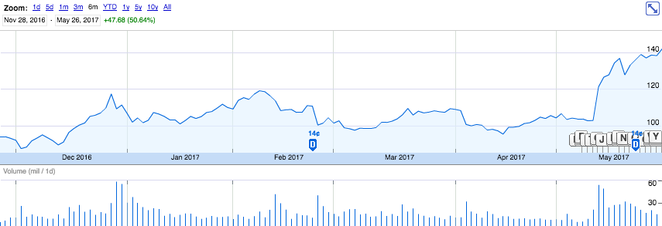NVIDIA was first listed on the NASDAQ stock exchange on the 22nd of January, 1999 and had a price on $1.64 (USD).

Figure NVIDIA Corporation's stock price over the past 6 months

From the beginning of the past 6 months on the 28th of November, 2016 till the 9th of May, 2017 NVIDIA’s stock price remained mostly static around the price of $109.45 with minor fluctuations in the price over the time period. (Figure 1) On the 10th of May, 2017 NVIDIA Corporation reported a stellar result for the fiscal 2018 Q1 and a driverless car deal with Toyota. The stock price increased from $102.94 to $121.29 the company then settled around $137.03.

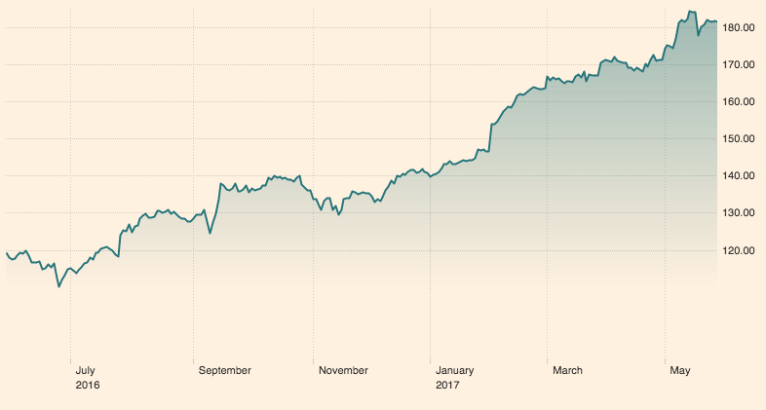

The sector that NVIDIA Corporation belongs to (Technology Hardware, Storage and Peripheral, 45202030) Has been on the steady rise over the past 12 months. The starting price was roughly $120 and has ended at roughly $180. This could be due to the increasing reliance of technological systems and the need for more powerful computer systems because of the increasing use of these systems.

Figure Technology Hardware, Storage and Peripheral (45202030) sector performance over the past year

**MYP Individuals & Societies - Year 5 Criteria**

Criterion A: Knowing and Understanding

At the end of year 5, students should be able to:

i) use a wide range of terminology in context

ii) demonstrate knowledge and understanding of subject-specific content and concepts through developed descriptions, explanations and examples.

**MYP ASSESSMENT CRITERIA – LEVELS OF ACHIEVEMENT**

|  |  |  |
| --- | --- | --- |
| **Level** | **Individuals & Societies – Criterion A**  **(Knowing and Understanding)** | **✓** |
| **0** | The student does not reach a standard described by any of the descriptors given below. |  |
| **1-2** | The student:   * uses **limited** relevant terminology * demonstrates **basic** knowledge and understanding of content and concepts with **minimal** descriptions and/or examples. |  |
| **3-4** | The student:   * uses **some** terminology **accurately** and **appropriately** * demonstrates **adequate** knowledge and understanding of content and concepts through **satisfactory** descriptions, explanations and examples. |  |
| **5-6** | The student:   * uses a range of terminology **accurately** and **appropriately** * demonstrates **substantial** knowledge and understanding of content and concepts through **accurate** descriptions, explanations and examples. |  |
| **7-8** | The student:   * **consistently** uses **a wide range** of terminology **effectively** * demonstrates **detailed** knowledge and understanding of content and concepts through **thorough, accurate** descriptions, explanations and examples. |  |

Indicating Level ________ for Criterion A

Criterion B: Investigating

At the end of Year 5, students should be able to:

i) formulate a clear and focused research question and justify its relevance

ii) formulate and follow an action plan to investigate a research question

iii) use research methods to collect and record appropriate, varied and relevant information

iv) evaluate the process and results of the investigation.

**MYP ASSESSMENT CRITERIA – LEVELS OF ACHIEVEMENT**

|  |  |  |
| --- | --- | --- |
| **Level** | **Individuals & Societies – Criterion B**  **(Investigating)** | **✓** |
| **0** | The student does not reach a standard described by any of the descriptors below. |  |
| **1-2** | The student:   * formulates a research question that is clear **or** focused and **describes** its relevance. * formulates a **limited** action plan to investigate a research question or does not follow a plan * collects and records **limited** information, not always consistent with the research question * makes a **limited** evaluation of the process and results of the investigation. |  |
| **3-4** | .  The student:   * formulates a research question that is **clear** and **focused** and **describes** its relevance in detail * formulates and **somewhat** follows a **partial** action plan to investigate a research question * uses a research method(s) to collect and record **mostly relevant** information * evaluates **some** aspects **of** the process and results of the investigation. |  |
| **5-6** | The student:   * formulates a **clear** and **focused** research question and **explains** its relevance * formulates and follows a **substantial** action plan to investigate a research question * uses research method(s) to collect and record **appropriate, relevant** information * **evaluates** the process and results of the investigation. |  |
| **7-8** | The student:   * formulates a **clear** and **focused** research question and **justifies** its relevance * formulates and **effectively** follows a **comprehensive** action plan to investigate a research question * uses research methods to collect and record **appropriate, varied and relevant** information * **thoroughly** evaluates the investigation process and results |  |

Indicating Level ________ for Criterion B

Criterion C: Communicating

At the end of Year 5, students should be able to:

i) communicate information and ideas effectively using an appropriate style for the audience and purpose

ii) structure information and ideas in a way that is appropriate to the specified format

iii) document sources of information using a recognised convention.

**MYP ASSESSMENT CRITERIA – LEVELS OF ACHIEVEMENT**

|  |  |  |
| --- | --- | --- |
| **Level** | **Individuals & Societies – Criterion C**  **(Communicating)** | **✓** |
| **0** | The student does not reach a standard described by any of the descriptors below. |  |
| **1-2** | The student:   * communicates information and ideas in **a limited way**, using a style that is **limited** in its appropriateness to the audience and purpose * structures information and ideas according to the specified format in a **limited way** * documents sources of information in a **limited way.** |  |
| **3-4** | The student:   * communicates information and ideas **satisfactorily** by using a style that is **somewhat** appropriate to the audience and purpose * structures information and ideas in a way that is **somewhat** appropriate to the specified format * **sometimes** documents sources of information using a recognised convention. |  |
| **5-6** | The student:   * communicates information and ideas **accurately** by using a style that is **mostly** appropriate to the audience and purpose * structures information and ideas in a way that is **mostly** appropriate to the specified format * **often** documents sources of information using a recognised convention. |  |
| **7-8** | The student:   * communicates information and ideas **effectively** and **accurately** by using a style that is **completely** appropriate to the audience and purpose * structures information and ideas in a way that is **completely** appropriate to the specified format * **consistently** documents sources of information using a recognised convention. |  |

Indicating Level ________ for Criterion C

Criterion D: Thinking Critically

At the end of Year 5, students should be able to:

i) discuss concepts, issues, models, visual representation and theories

ii) synthesise information to make valid, well-supported arguments

iii) analyse and evaluate a wide range of sources/data in terms of origin and purpose, examining values and limitations

iv) interpret different perspectives and their implications.

**MYP ASSESSMENT CRITERIA – LEVELS OF ACHIEVEMENT**

|  |  |  |
| --- | --- | --- |
| **Level** | **Individuals & Societies – Criterion D**  **(Thinking Critically)** | **✓** |
| **0** | The student does not reach a standard described by any of the descriptors below. |  |
| **1-2** | The student:   * **analyses** concepts, issues, models, visual representation and theories to a **limited extent** * **summarises** information to a **limited extent** to make arguments * **describes a limited number of** sources/data in terms of origin and purpose and recognises **few** values and limitation * **identifies** different perspectives and **minimal** implications. |  |
| **3-4** | The student:   * **analyses** concepts, issues, models, visual representation and theories * **summarises** information to make arguments * **analyses and/or evaluates** sources/data in terms of origin and purpose, recognising **some** values and limitations * **interprets** different perspectives and **some** of their implications |  |
| **5-6** | The student:   * **discusses** concepts, issues, models, visual representation and theories * **synthesises** information to make **valid** arguments * **effectively analyses** and **evaluates a range** of sources/data in terms of origin and purpose, recognising values and limitations * **interprets** different perspectives and their implications. |  |
| **7-8** | The student:   * completes a **detailed discussion** of concepts, issues, models, visual representation and theories * **synthesises** information to make **valid, well-supported** arguments * **effectively analyses** and **evaluates a wide range** of sources/data in terms of origin and purpose, recognising values and limitations * **thoroughly interprets** a **range** of different perspectives and their implications. |  |

Indicating Level ________ for Criterion D